COLONIAL NEWS
Health Committee Newsletter May 2023

Welcome to the Albert Gallatin School District Health Committee’s monthly newsletter. Each month this publication will provide our district with health and fitness information. Our goal is for our students, families, and staff to use this information to make healthy decisions and to live a healthy active lifestyle.

Sun Safety Tips
- Limit your time in the sun, especially between 10 a.m. and 2 p.m., when the sun’s rays are most intense.
- Wear clothes to cover skin exposed to the sun, such as long-sleeve shirts, pants, sunglasses, and broad-brim hats.
- Use broad spectrum sunscreens with an SPF value of 15 or higher regularly and as directed.
- Read the label to ensure you use your sunscreen correctly.
- Consult a health care professional before applying sunscreen to infants younger than 6 months.
- Apply sunscreen to all uncovered skin, especially your nose, ears, neck, hands, and feet.
- Reapply sunscreen at least every two hours. Apply more often if you’re swimming or sweating.
(adapted from Source: www.fda.gov)
For more information visit www.fda.gov

Bicycle Safety Tips
Bicycling is great exercise for adults and children. Here are some safety tips to remember when going out for a bike ride:
- Don’t wear headphones or talk on your cellphone while riding your bike.
- Wear brightly colored clothes so that drivers can easily see you.
- Ride in the same direction as the flow of traffic.
- At intersections, stop at stop signs and obey traffic lights as cars do.
- Check for traffic before turning.
- Use correct hand or arm signals.
- Stop first before riding out into a street.
- Wear a helmet.
- Avoid getting loose pants legs, straps or shoelaces caught in the spokes of the bicycle chain.
- Wear proper shoes. Do not ride barefoot, wearing sandals or flip-flops.
(adapted from Source: www.nhtsa.dot.gov)

For more information visit
www.nhtsa.dot.gov
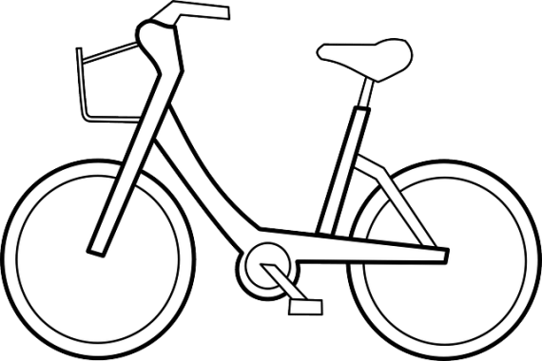

Prepared by Lisa Sumey, Central Office Secretary

Recipe of the Month

Fruit Salad with Honey Lime Dressing

Ingredients
- 1 lb. of strawberries, chopped
- 4 kiwis peeled and chopped
- 1 ½ cups of blueberries
- 2 bananas, sliced
- 1 large apple, diced

Honey Lime Dressing

Whisk together:
- ½ cup honey
- 1 lime, juiced and zested

Instructions
- In a large bowl, add chopped fruit
- Pour Honey Lime Dressing over the fruit
- Gently toss to coat
- Cover with plastic wrap
- Refrigerate for 20 minutes before serving

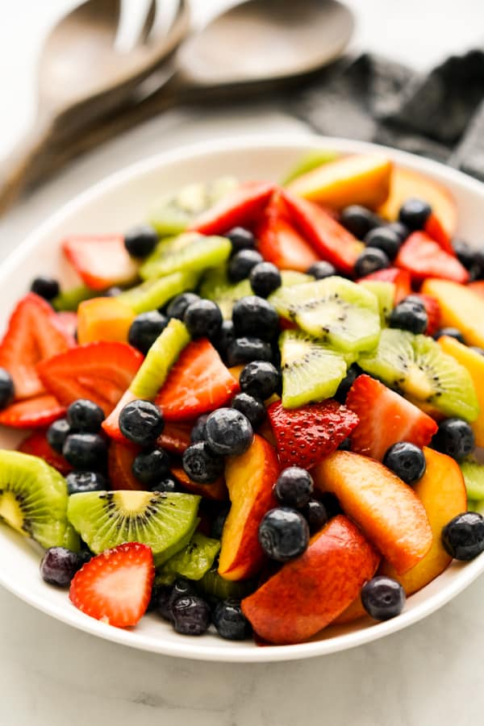

DID YOU KNOW?

Fruits are an excellent source of essential vitamins and minerals. They are high in fiber. Fruits also provide a wide range of health-boosting antioxidants, including flavonoids. Eating a diet high in fruits and vegetables can reduce a person's risk of developing heart disease, cancer, inflammation, and diabetes.
(copied from Source: Medical News Today)

This Photo by Unknown Author is licensed under CC BY-NC

